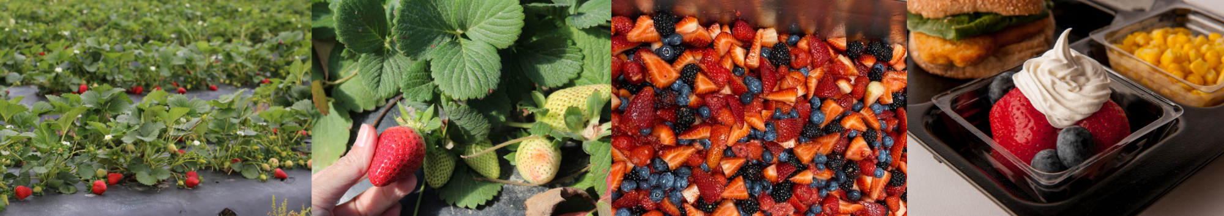

Hoke County Schools Breakfast Menus for May 2024
PreK Schools
Monday | Tuesday | Wednesday | Thursday | Friday
 |  | May 1  French Toast Minis  Assorted Cereal  Mandarin Oranges  Lowfat or Fat Free Milk | May 2  Chicken Biscuit  Assorted Cereal  Assorted Juice  Low-Fat or Fat-Free Milk | May 3  Mini Waffles  Assorted Cereal  Mixed Fruit  Low-Fat or Fat-Free Milk
May 6  Pancake on Stick  Assorted Cereal  Diced Peaches  Low-Fat or Fat-Free Milk | May 7  Banana Muffin  Assorted Cereal  Assorted Juice  Low-Fat or Fat-Free Milk | May 8  French Toast Stix  Assorted Cereal  Mandarin Oranges  Low-Fat or Fat-Free Milk | May 9  Sausage Biscuit  Assorted Cereal  Assorted Juice  Low-Fat or Fat-Free Milk | May 10  Mini Waffles  Assorted Cereal  Mixed Fruit  Low-Fat or Fat-Free Milk
May 13  Breakfast Bites  Assorted Cereal  Diced Peaches  Low-Fat or Fat-Free Milk | May 14  Apple Muffin  Assorted Cereal  Assorted Juice  Low-Fat or Fat-Free Milk | May 15  French Toast Minis  Assorted Cereal  Mandarin Oranges  Lowfat or Fat Free Milk | May 16  Chicken Biscuit  Assorted Cereal  Assorted Juice  Low-Fat or Fat-Free Milk | May 17  Mini Waffles  Assorted Cereal  Mixed Fruit  Low-Fat or Fat-Free Milk
May 20  Pancake on Stick  Assorted Cereal  Diced Peaches  Low-Fat or Fat-Free Milk | May 21  Banana Muffin  Assorted Cereal  Assorted Juice  Low-Fat or Fat-Free Milk | May 22  French Toast Stix  Assorted Cereal  Mandarin Oranges  Low-Fat or Fat-Free Milk | May 23  Sausage Biscuit  Assorted Cereal  Assorted Juice  Low-Fat or Fat-Free Milk | May 24  Mini Waffles  Assorted Cereal  Mixed Fruit  Low-Fat or Fat-Free Milk
May 27 | May 28  Apple Muffin  Assorted Cereal  Assorted Juice  Low-Fat or Fat-Free Milk | May 29  French Toast Minis  Assorted Cereal  Mandarin Oranges  Lowfat or Fat Free Milk | May 30  Chicken Biscuit  Assorted Cereal  Assorted Juice  Low-Fat or Fat-Free Milk | May 31

Families Making the Connection

Strawberries are Sweet!
Strawberries are fruits that grow on small plants. Strawberries can be available year-round. Peak season in the United States is May to July and in North Carolina is mid-April to mid-June. Did you know May is National Strawberry Month?

The Strawberry is the official North Carolina State Red Berry. North Carolina is the 4th largest strawberry producer in the nation. North Carolina has many “pick your own” farms. Find one near you at GottoBeNC.com.

Strawberries change colors as they ripen. They start as green and go from white to pink and finally to red when they are ripe and ready to be harvested. Strawberries will not ripen after picking. Choose strawberries with a solid red color and very little green or white. Strawberries should not have any mold or damage. The green caps should look fresh.
Strawberries are fun to eat fresh, whole or sliced, as a snack or side to a meal. You can add them to salads. Mix with low fat yogurt. Use as a topping for waffles, pancakes, or cereal. Or blend into smoothies. Wash your strawberries thoroughly under clean, running water before preparing or eating.

Strawberries are a superfood—packed with nutrients. Not only are strawberries deliciously sweet but they also help keep you healthy. Strawberries are an excellent source of vitamin C and a good source of fiber. A cup of whole strawberries has around 50 calories and 140 percent of the vitamin C Daily Value. Strawberries are cholesterol free and low in fat and sodium. Eight strawberries contain more vitamin C than one orange! Learn more about strawberries and other fruits and vegetables at https://bit.ly/3c30kws.

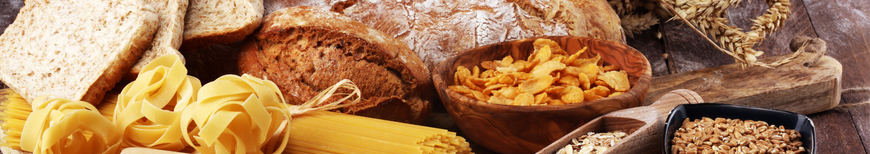

Hoke County Schools Lunch Menus for May 2024
Monday | Tuesday | Wednesday | Thursday | Friday
 | 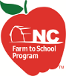  *NC Farm-to-School | May 1  Deep Dish Cheese Pizza  Pinto Beans  Mixed Fruit  Lowfat or Fat Free Milk | May 2  Oven Roasted Chicken  Steamed Broccoli  Dinner Roll  Mixed Fruit  Lowfat or Fat Free Milk | May 3  Hot Dog on Bun  Seasoned French Fries  *Fresh NC Strawberries  Lowfat or Fat Free Milk
May 6  Grilled Chicken Biscuit  Steamed Broccoli  Pineapple Tidbits  Lowfat or Fat Free Milk | May 7  Chicken Quesadilla  Buttered Corn  Salsa  *Fresh NC Apple Wedges  Lowfat or Fat Free Milk | May 8  Spaghetti w/Meatballs  Steamed Carrots  Mixed Fruit  Lowfat or Fat Free Milk | May 9  Mandarin Orange Chicken  Stir Fry Vegetables  *Steamed Heirloom Carolina Gold Rice  Mandarin Oranges  Lowfat or Fat Free Milk | May 10  Sloppy Joe on Bun  Baked Beans  *Fresh NC Strawberries  Lowfat or Fat Free Milk
May 13  Chicken Nuggets  Steamed Broccoli  *Fresh NC Apple Wedges  Dinner Roll  Lowfat or Fat Free Milk | May 14  Meatball Sub  Pinto Beans  Diced Peaches  Lowfat or Fat Free Milk | May 15  Beefy Nachos  Buttered Corn  Salsa  Mixed Fruit  Lowfat or Fat Free Milk | May 16  General Tso’s Chicken  Stir Fry Vegetables  *Steamed Heirloom Carolina Gold Rice  *Fresh NC Apple Wedges  Lowfat or Fat Free Milk | May 17  Hot Dog on Bun  Seasoned Sweet Potato Waffle Fries  *Fresh NC Strawberries  Lowfat or Fat Free Milk
May 20  Chicken Tenders & Dutch Waffle  Hash Rounds  *Fresh NC Apple Wedges  Lowfat or Fat-Free Milk | May 21  Soft Shell Beef Taco  Black Beans  Salsa  *Fresh NC Blueberries  Lowfat or Fat Free Milk | May 22  Hamburger Steak w. Gravy  Glazed Carrots  *Steamed Heirloom Carolina Gold Rice  *Fresh NC Apple Wedges  Lowfat or Fat Free Milk | May 23  Asian Zing Meatballs  *Fresh NC Steamed Broccoli  *Steamed Heirloom Carolina Gold Rice  Diced Peaches  Lowfat or Fat Free Milk | May 24  Cheeseburger on Bun  Seasoned French Fries  *Fresh NC Strawberries  Lowfat or Fat Free Milk
May 27 | May 28  Wedge Pepperoni Pizza  Steamed Carrots  Mixed Fruit  Lowfat or Fat Free Milk | May 29  Chick Fillet Sandwich  *Fresh NC Steamed Broccoli  Pineapple Tidbits  Lowfat or Fat Free Milk | May 30  Hot Dog on Bun  Baked Beans  Diced Peaches  Lowfat or Fat Free Milk | May 31

